Title – 6th grade English SLO
Content Area – English Language Arts
Grade Level – 6th grade
Students – 92 students in my four sections of Gr. 6 ELA Interval of Instruction – School Year 2014-2015
Main  Criteria | Element | Description
Essential Question: What are the most important knowledge/skill(s) I want my students to attain by the end of the interval of instruction?
Priority of Content | Objective  Statement | Students will be able to write arguments to support claims with clear reasons, drawing relevant evidence from literary or informational texts to support analysis and reflection, and including the acknowledgement of opposing claims, references to credible sources, a concluding statement, and a formal style.
 | Rationale | As students transition into middle school it is increasingly important for them to develop their writing of arguments, particularly in response to literary and informational texts. This is one of the three Text Types addressed by the Common Core State Standards for writing. Furthermore, it is a type of writing that will be required of them throughout the secondary grades, both in English Language Arts and other content areas. Baseline writing prompt data, as well as my observations over the past seven years teaching this grade level, indicate that writing arguments is an area of relative weakness in students’ writing, as opposed to opinion pieces, narratives, and even informative/explanatory writing.
 | Aligned  Standards | W.6.1: Write arguments to support claims with clear reasons and relevant evidence  - Introduce claim(s) and organize the reasons and evidence clearly.  - Support claim(s) with clear reasons and relevant evidence, using credible sources and demonstrating an understanding of the topic or text.  - Use words, phrases, and clauses to clarify the relationships among claim(s) and reasons.  - Establish and maintain a formal style.  - Provide a concluding statement or section that follows from the argument presented.  W.6.9: Draw evidence from literary or informational texts to support analysis, reflection, and research.  - Apply grade 6 Reading standards to literature (e.g., “Compare and contrast texts in different forms or genres [e.g., stories and poems; historical novels and fantasy stories] in terms of their approaches to similar themes and topics”).  - Apply grade 6 Reading standards to literary nonfiction (e.g., “Trace and evaluate the argument and specific claims in a text, distinguishing claims that are supported by reasons and evidence from claims that are not.”).  L.6.1: Demonstrate command of the conventions of standard English grammar and usage when writing or speaking.  - Ensure the pronouns are in the proper case (subjective, objective, possessive).  - Use intensive pronouns (e.g., myself, ourselves).  - Recognize and correct inappropriate shifts in pronoun number and person.  - Recognize and correct vague pronouns (i.e., ones with unclear or ambiguous antecedents).  L6.2: Demonstrate command of the conventions of standard English capitalization, punctuation, and spelling when writing.  a. Use punctuation (commas, parentheses, dashes) to set off nonrestrictive/parenthetical  elements.

b. Spell correctly.
L.6.3: Use knowledge of language and its conventions when writing, speaking, reading, or listening.
- Vary sentence patterns for meaning, reader/listener interest, and style.
- Maintain consistency in style and tone.
RL.6.1/RI.6.1: Cite textual evidence to support analysis of what the text says explicitly as well as inferences drawn from the text.
RL.6.2/RI.6.2: Determine a theme or central idea of a text and how it is conveyed through particular details; provide a summary of the text distinct from personal opinions and judgments.
Essential Question: Where are my students now (at the beginning of instruction) with respect to the objective?
 | Baseline Data / Information | Prior to the first day of school, I reviewed samples from students’ 5th grade writing portfolios and used them to create three initial groups of students: those whose writing is on grade level, those whose writing is below grade level, and those whose writing is above grade level. However, because most of the pieces in the portfolios were examples of narrative, opinion, and informational/explanatory writing, I decided to confirm these groupings with a baseline assessment of writing an argument in response to informational text. I scored the writing prompts using the District Middle School Writing Rubric, which identifies 5 levels of performance ranging from Below Basic to Advanced. After considering both sources of baseline data, I determined the following tiers:  Below Basic = 15 students  Basic = 36 students  Approaching Standard = 29 students Meeting Standard = 10 students Advanced = 2 students
Essential Question: Based on what I know about my students, where do I expect them to be by the end of the interval of instruction and how will they demonstrate their knowledge/skills?
Rigor of  Target | Target(s) | - 80% of all students will increase one level.  - The other 20% of students will show growth.
 | Rationale for  Target(s) | This target is rigorous yet attainable since my students are starting so far below grade-level expectations. All students are expected to show growth and the amount of students approaching and meeting the standard will increase substantially with these targets.
Quality of Evidence | Evidence  Source(s) | Students will produce two pieces of writing during the first two weeks of June. Week 1: Argument in response to literature  Week 2: Argument in response to informational text  The texts and writing prompts were developed in consult with the other 6th grade ELA teacher and one 7th grade ELA teacher. They were approved by the English Department Chair.  Students will read the pieces of literature or informational text in class, have time to outline their response and select supporting evidence, and respond in writing. Our block scheduling will allow for reading and drafting on Day 1 and revision and completion on Day 2. The other 6th grade ELA teacher, who is sharing this SLO, and I will randomly score our students’ writing pieces each week, using the District Middle School Writing Rubric. In addition, the English Department Chair has agreed to double-score 10% of writing pieces.

Evolving Sample for Grade 6 ELA SLO: Writing Arguments in Response to Text

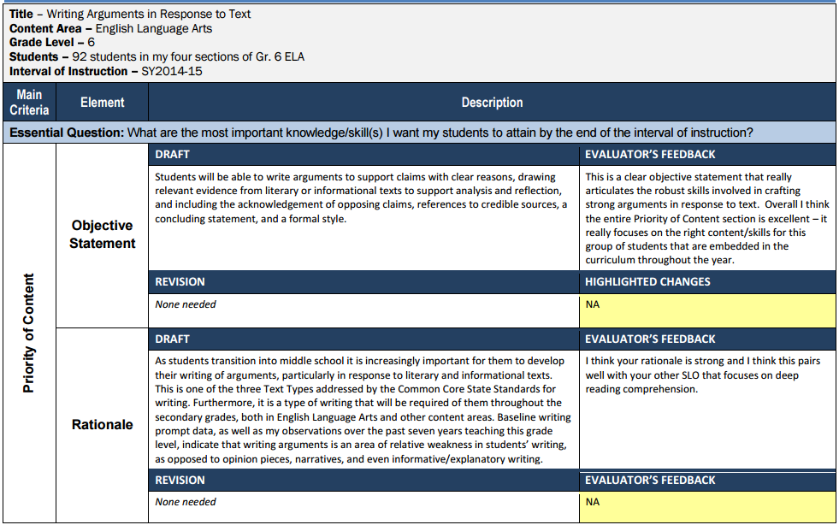
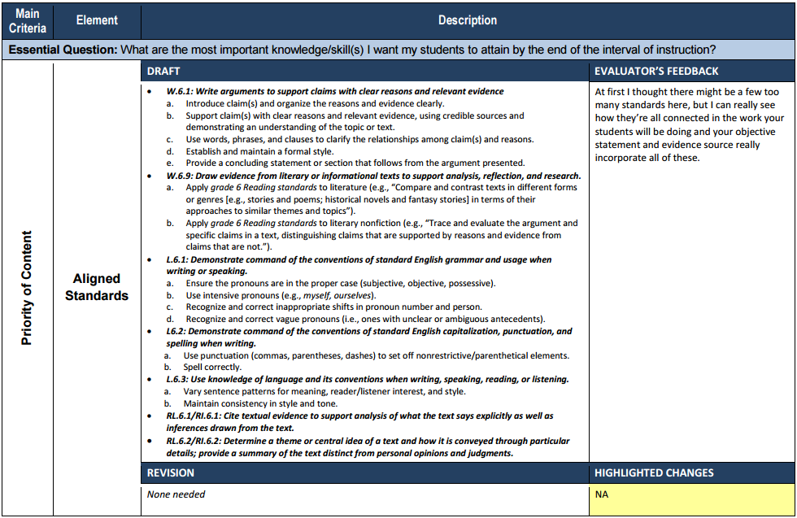
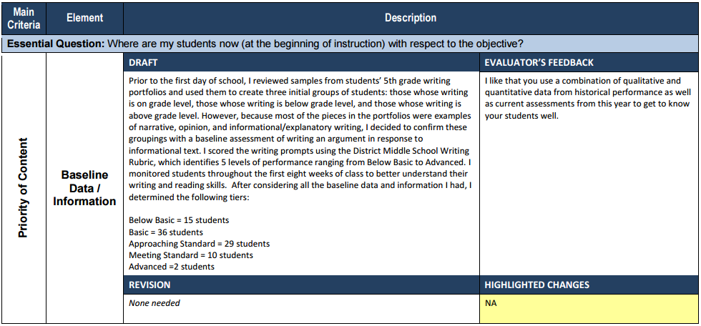

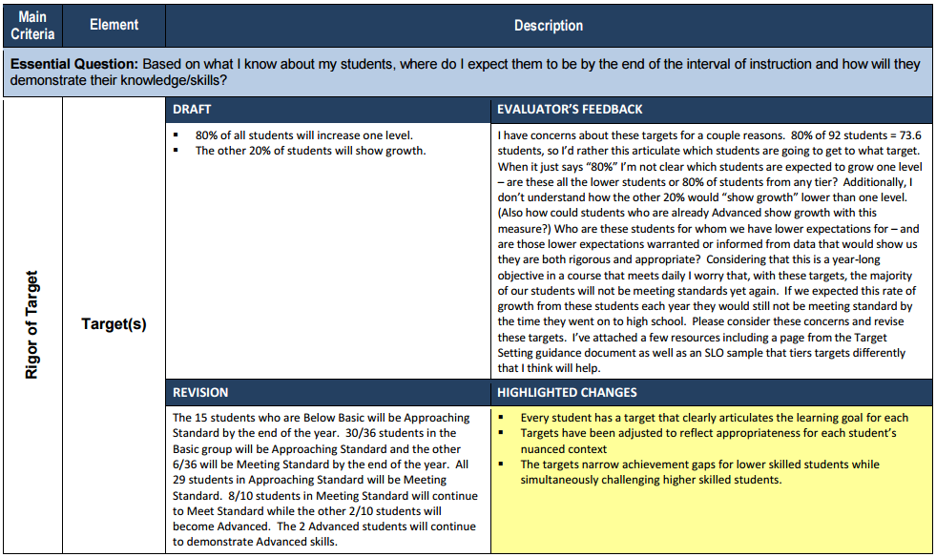

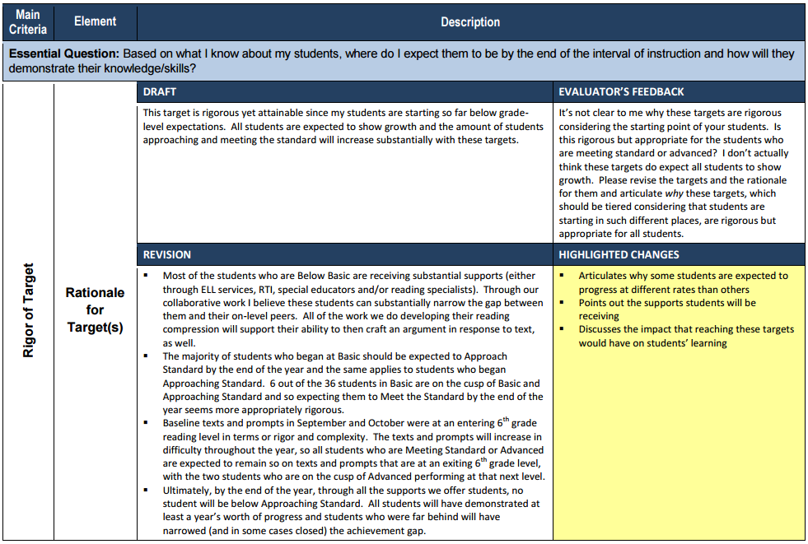
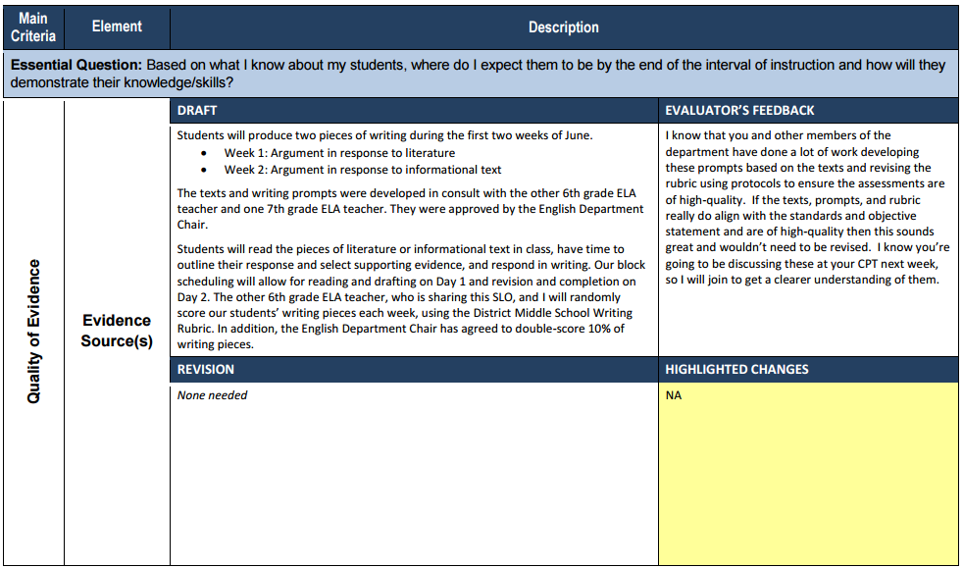

Title – 7th grade Science SLO Content Area – Science Grade Level – 7th grade
Students – 76 students in my three sections of 7th grade science
Interval of Instruction – School Year 2014-2015
Main  Criteria | Element | Description
Essential Question: What are the most important knowledge/skill(s) I want my students to attain by the end of the interval of instruction?
Priority of Content | Objective  Statement | By the end of the year students will be able to demonstrate proficiency on Astronomy and Earth Science benchmark assessments.
 | Rationale | Students often arrive to middle school without a breadth or depth of science instruction. While they may have learned about aspects of anatomy or earth science in previous years my work with them this year will focus on retaining knowledge at a deeper level.
 | Aligned  Standards | ESS1 (7-8)-1 – Students demonstrate an understanding of processes and change over time within earth systems by: 1a citing evidence and developing a logical argument for plate movement using fossil evidence, layers of sedimentary rock, location of mineral deposits, and shape of the continents.  ESS1 (7-8)-3 3a evaluating slow processes (e.g. weathering, erosion, mountain building, sea floor spreading) to determine how the earth has changed and will continue to change over time. 3b evaluating fast processes (e.g. erosion, volcanoes and earthquakes) to determine how the earth has changed and will continue to change over time. 3c Investigating the effect of flowing water on landforms (e.g. stream table, local environment).
Essential Question: Where are my students now (at the beginning of instruction) with respect to the objective?
 | Baseline Data / Information | The only historical data I could use was their 6th grade science grades which reflect mastery  of different content:  A = 34 students  B = 28 students  C = 10 students  A pre-assessment was completed to assess their current level of knowledge in regards to the objective statement. The assessment had 50 multiple choice questions on a range of Astronomy and Earth Science facts and skills. The results were:  17 students scored between 0%-20% 27 students scored between 21%-40% 19 students scored between 41%-60% 8 students scored between 61%-80% 5 students did not take the assessment.

Essential Question: Based on what I know about my students, where do I expect them to be by the end of the interval of instruction and how will they demonstrate their knowledge/skills?
Rigor of Target | Target(s) | I expect that 75% of my students will pass each assessment by earning a score of 70% which would show proficiency.
 | Rationale for  Target(s) | This target is rigorous yet attainable since my students are starting with minimal content knowledge.
Quality of  Evidence | Evidence  Source(s) | Students will complete a benchmark assessment for Astronomy and another for Earth Science. The assessments have been approved by the Department Chair and involve a range of question types at multiple DOK levels. The assessments will be completed in class and administered by me, however my Department Chair will double-score 10% of them with me for calibration. Formative assessments will be used on a daily basis during instruction to assess where students are at particular points throughout the units.

Building Administrator SLO

Title – Building Administrator ELA Student Learning Objective
Content Area – ELA
Grade Level – 6th – 8th
Students – All students in grades 6th – 8th (328 total)
Interval of Instruction – Year
Main Criteria | Element | Description
Essential Question: What are the most important knowledge/skill(s) I want my students to attain by the end of the interval of instruction?
Priority of Content | Objective Statement | All students will improve their reading comprehension of informational text, as measured by their ability to identify the general topic of a text, use explicitly-stated information to answer questions about the text, and make inferences and/or draw conclusions about central ideas that are relevant to the text.
 | Rationale | Based on end-of-year district assessments and state assessment data, our students are weaker in their ability to respond to informational texts than to literary texts. In addition, the high school educators have indicated that our eighth grade graduates are unprepared for honors, or other upper-level classes, which are reading and writing intensive. We believe increasing success in literacy skills focused on informational texts will lead to increased achievement in all classes at our school and when students enter high school. Furthermore, this is in alignment with CCSS emphasis on literary text as students move into the secondary grades.
Essential Question: Where are my students now (at the beginning of instruction) with respect to the objective?
 | Baseline Data / Information | The beginning–of-year district benchmark assessment data (administered in English classes) indicates that 30% of students exceeded the standard, 30% met the standard, 20% were below standard, and 20% were significantly below the standard on reading comprehension of informational text. These results are consistent with past school data. Also, beginning-of-year Social Studies benchmark assessments corroborate these findings.
Essential Question: Based on what I know about my students, where do I expect them to be by the end of the interval of instruction and how will they demonstrate their knowledge/skills?
Rigor of Target | Target(s) | Based on beginning of year benchmark assessments and student data taken from portions of district-wide tests in English, Social Studies, and Science, students have been sorted into four tiers:  - The 187 students who exceeded the standard will continue to exceed the standard using the grade appropriate rubric on the end of year district assessment. However, since these students are already exceeding the standard the text complexity will be increased for this group in order to continue to challenge them.  - The 187 students who met the standard will be divided into 2 tiers:  - 62 of the students will exceed the standard on the end of year district assessment  - The other 125 will continue to meet the standard but with increased text complexity for the grade-level.  - The 125 students who were below the standard will move up one level to meet the standard on the end of year assessment.  - The 125 students who were significantly below the standard will be divided into two tiers:  - 75 of the students will move up two levels to meet the standard on the end of year district assessment  - The other 50 students will move one level to below standard on the end of year district assessment. While these students are still not meeting the standard. They are moving up and beginning to close the gap.  - Intense supports will be put in place for the students that are significantly below the standard and continuous progress monitoring will take place to ensure students are on track to meet their goals.
 | Rationale for Target(s) | These targets set the expectation that all students will make progress, but that those students who are the furthest behind will make more progress, thereby narrowing the gap between them and their on-grade-level peers. We believe they will be attainable through increased supports to our most struggling students and more frequent progress monitoring.
Quality of Evidence | Evidence Source(s) | Quarterly assessments for each grade level focusing on informational texts have been created collaboratively between English, Science, and Social Studies teachers at our school and with consultation from our district’s high school department heads. The passages include short articles, essays, and other informational texts. Students are asked to read, analyze, and respond through multiple choice and open response items.  This assessment will be administered by grade-level teams the last week of each quarter. The quarterly assessments will be scored collaboratively by the 6th, 7th, and 8th grade teams using department meetings to calibrate, score, and discuss data. The data will be reviewed quarterly and supports will be put into place for students that are having difficulty in order to help them achieve their goals on the end of year district assessment.

Student Learning/Outcome Objective Scoring Process Map

The SLO/SOO Scoring Process Map below outlines the specific steps an evaluator should take to determine if individual SLOs/SOOs are Exceeded, Met, Nearly Met, or Not Met.
Yes
Yes
No
No
Did a substantial amount of students greatly exceed their targets?
How many students reached their targets?
Did all or almost all students reach their targets?
Were most students close to their targets?
Exceeded
Met
Nearly Met
Not Met
Yes
No

Additional Student Learning/Outcome Objective Scoring Guidance
To help further clarify the definitions of Exceeded, Met, Nearly Met, and Not Met, RIDE has developed the following scoring guidelines that LEAs can choose to adopt.

NOTE: The additional SLO/SOO scoring guidance above does not eclipse local LEA policy. LEAs have the flexibility to adopt the additional SLO/SOO scoring guidance, create their own guidance, or choose to continue to use the Exceeded, Met, Nearly Met, and Not Met descriptions exclusively. For example, LEAs may want to create specific guidance for scoring SLOs that represent a small number of students.

