Rhode Island Data Set Worksheets
The worksheets are set up to allow you to filter the data in each column to find the data you want.

Before You Begin
If you are unfamiliar with filtering in Microsoft Excel, see the tools at Microsoft’s web site:
http://office.microsoft.com/en-us/excel-help/video-filter-data-by-using-an-autofilter-VA101809989.aspx?CTT=1
http://office.microsoft.com/en-us/excel-help/quick-start-filter-data-by-using-an-autofilter-HA010370616.aspx?CTT=3

The Data Set Fields
- ID – A unique field identifier
- Dist No –The number for the school district
- Location (Loc) – School or department for which money is being used
- Location Type (Loc Type) – The school or department type for which money is being used
- Fund – Type of Source of money
- Function (Func) – Activity for which money is being used
- Program (Prog) – Broad Objective for which money is being used
- Subject (Sub) – Curriculum or Detailed Objective for which money is being used
- Object (Obj) – Budget Classification for which money is being used
- Job Classification (JC) – Job Classification for which money is being used for Compensation and Benefits only
- Actual – Actual expenditure amounts in dollars
The fields above are the code fields. Descriptions have been provided for all expenditure code fields and for those revenue and balance sheet fields where meaningful data filtering can be performed.

Plan Your Data Search
It is important to have a clear objective of the data you want before you begin filtering. It might be helpful to state your objective in a sentence. For example, “I am looking for all general fund expenditures for salaries paid to teachers.” Or, “I am looking for special education transportation expenditures for elementary schools.” Or, “I am looking for food service revenues for district 100.”

Filtering
Let’s find the data from our first example: general fund expenditures for salaries paid to teachers. First, let’s break down the components and where to filter to find this information.
- General fund – this information will be found in the Fund column (Fund or Fund Description)
- Salary expenditures – this will be in the Object column (Obj or Object Description)
- Teachers – this will be further identified in the Job Class (JC or Job Class Description)
We’ll use the Description columns to make things easier.
  - Click on the filter dropdown arrow next to the Fund Description column header.
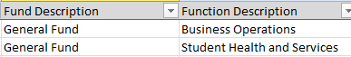
  - Click in the Search Box in the filter menu and type General Fund. Click on the OK button.
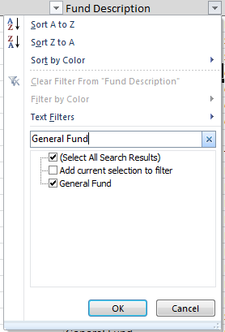
The data set should now be filtered to display only general fund expenditures. Now let’s filter for salaries.
  - Click on the filter dropdown arrow next to the Object Description column header. Click in the Search Box in the filter menu and type Salar.
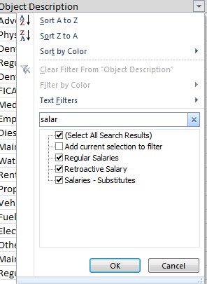
There are three different types of salaries. You will need to decide whether you want to include all of these types of salaries in your data. Let’s assume that you decide you only want regular salaries and substitute salaries.
  - Unclick the boxes for Retroactive Salary. Click the OK button.
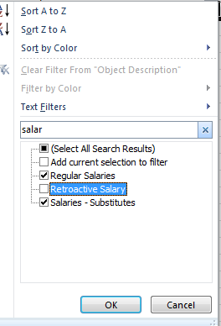
The data should now show regular salaries and salaries - substitute from the general fund. You are ready for the last step – filtering for teachers. Filtering for teachers requires multiple steps because you must first filter out any records that contain “Teacher Assistant” or “Teacher Aide”.
  - Click on the filter dropdown arrow next to the Job Class Description column header. Click on Text Filters and then on Custom Filters.
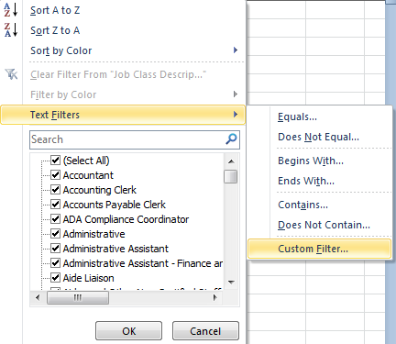
  - The Custom AutoFilter menu will appear. Fill out the menu so the Job Class Description field contains Teacher AND does not contain Assistant. Click the OK button.
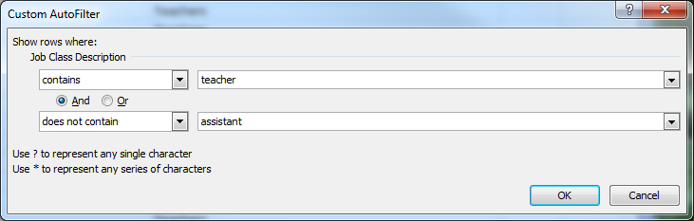
This takes care of the Teacher and Assistant part, but what about the Teacher Aide? You can only filter for two variables. You will have to go back to the list to uncheck the Teacher Aide categories if any are checked.
  - Click on the filter dropdown arrow next to the Job Class Description column header. Click in the Search Box in the filter menu and scroll down to Teacher Aide.
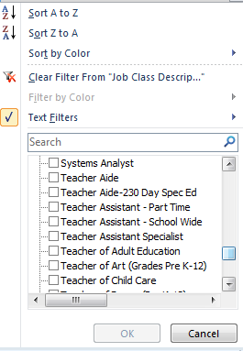
The boxes next to teacher aides are not checked, so there are no records included in the data set. Do not check them or you will include them with the teachers.
Note that this set of filters would return all teacher and substitute salaries regardless of the function. If you want teacher and substitute salaries for instructional functions, you would need to refine your question and also filter under the Function field.

