Innovation Districts
Running a Rubric Explorer Report for the 2012-2013 School Year

Professional Practice and Professional Foundations Rubric scores can be reviewed via the Rubric Explorer Reports link for all evaluation types. The report can be produced to examine the rubric scores of the district as a whole, by schools, by evaluators, by groups of educators or by individual educators.
Running the Rubric Explorer Report
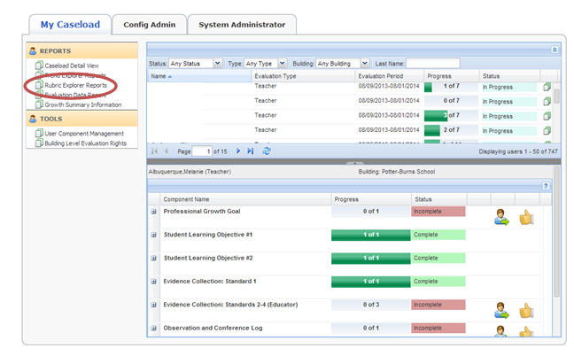
Log into your EPSS Dashboard. On your My Caseload tab click on Rubric Explorer Reports.

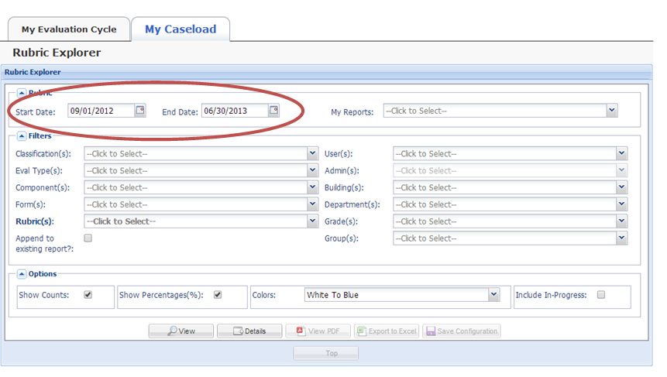
Set the dates to reflect the 2012-2013 school year.

Set the report criteria.
In this example, the evaluation type selected is teacher, but a report could be run to examine the rubric scores of any evaluation type used in your district with aligned rubrics in EPSS.
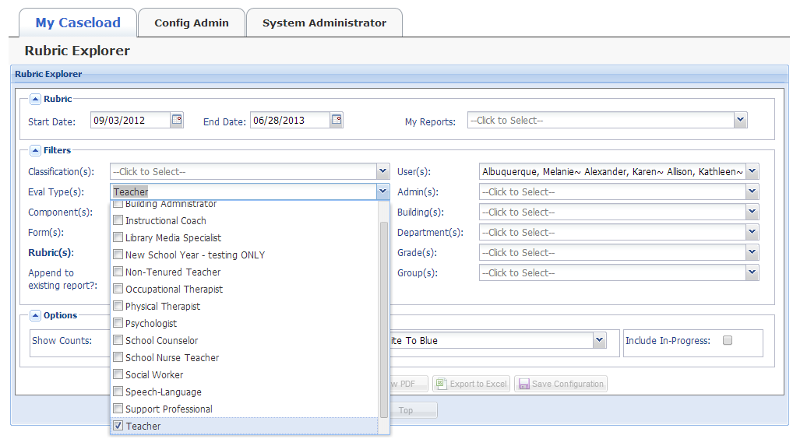
Choose the rubric that aligns to the components you wish to explore.
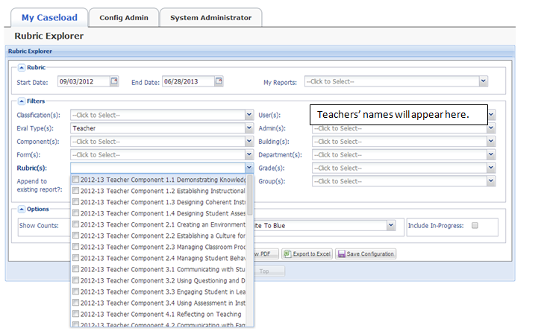
Once the component (s )(Ex. Evidence Collection) has been selected the screen will prompt you to choose a rubric. You may choose to select one or all of the components of the rubric to be included in the report.

Select the group of educators to include in the report.
All users on your caseload are automatically included by default but, narrowing the focus of the report can be done by selecting/deselecting teachers, by content area or grade level for example, using the User(s) drop down menu…
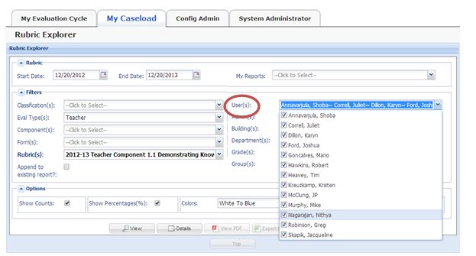
or by choosing an evaluator or group of evaluators using the Admin(s) drop down menu. You may also choose to run the report for a specific school or schools by selecting the school (s) using the Building (s) drop down menu. *Note: You may only view and filter report data based on your caseload.
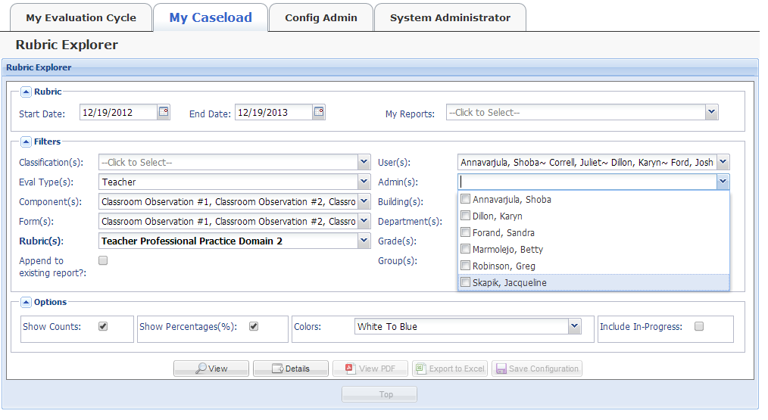
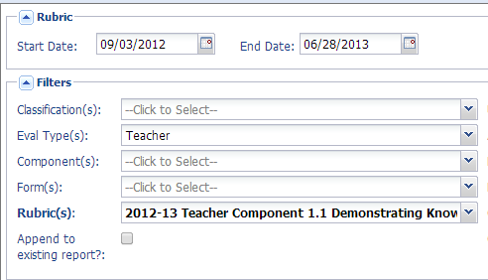

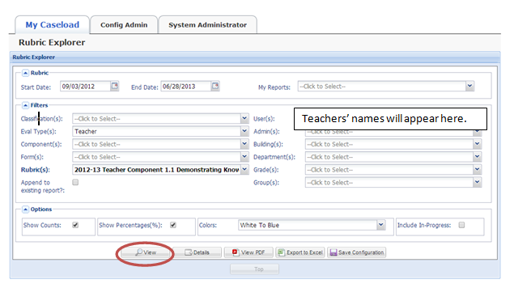
With all the criteria for the report selected click on the icon to run the report.
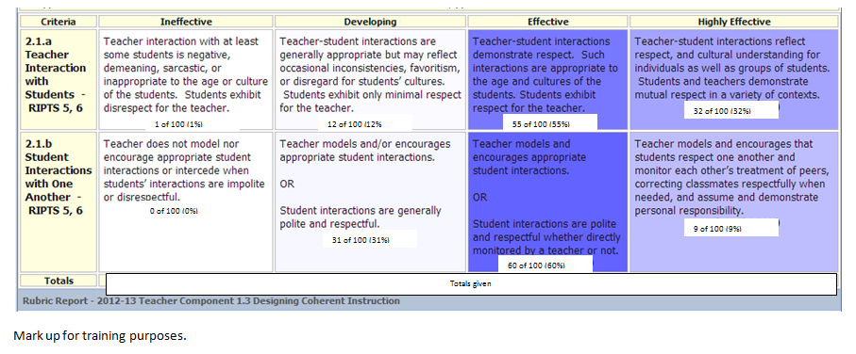
When you click on the icon a heat map report will open containing information about scores for each component selected for the report.

Hover over any component and score to see the names of the teachers who earned that score. Names will appear in a pop-up box.
Click on the component/score box for a printable list of teachers who earned that score.
Click on view PDF to open the report as a PDF.
As a PDF the document can be saved and/or printed.
You may also export the text of the report into an Excel document. As an Excel document the information can be sorted further using the data sort functionality within Microsoft Excel.

To save the report, within EPSS, for future reference select the icon. A pop-up menu will appear which will allow you to name and save your report.
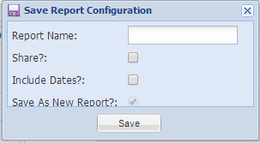

Once you have saved the report it can be accessed by using the drop down menu under
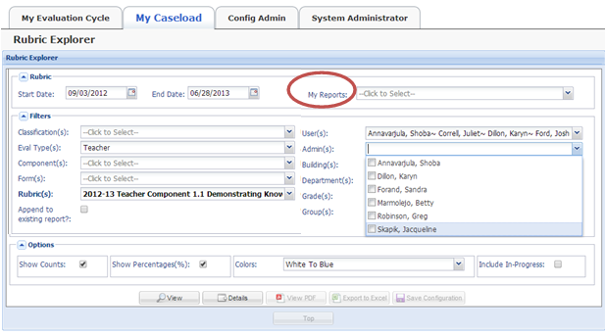
My Reports.

Looking Deeper into Component Scores Using Rubric Explorer

By selecting which educators, evaluators, or schools to include a report can be created that compares the scores of one group of educators, evaluators, or schools to another like group.
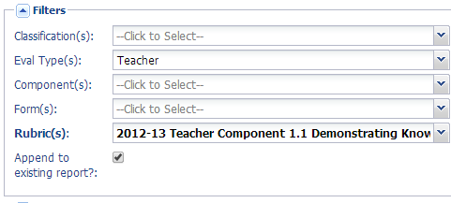
The Append to existing report functionality within Rubric Explorer enables you to run a report to compare rubric scores from School A to School B, teachers in one grade or subject area to another grade or subject area or the scores given by one evaluator to another evaluator. Follow the directions given in this packet to run one report; choose the first school, group of teachers, or evaluator and then click the view icon to produce the first report. Afterwards scroll to the top of the page and click the box for Append to existing report (see image below) , then select the criteria for the next report by choosing the school, group of teachers, or evaluator you wish to compare to the first group. Once you have selected your criteria, click the view icon to create the comparison report. The report will have the information from the first set of criteria followed by the information from the second set of criteria. Repeat this process to add another group of teachers, school or evaluators.

Ongoing Review of Component Scores to Highlight Strengths and Needs

The Rubric Explorer Report tool can be used throughout the year to highlight strengths and areas in need of improvement to help in planning professional development opportunities focused on teaching practices aligned to the components. Filtering tools on the Rubric Explorer allow for a specific focus of the reports. Using the Append to existing report functionality will allow reports that compare first observations to later observations. These reports can show growth in component scores and/or the impact professional development may be having on component scores.

