POLICY AND PROCEDURES
Rhode Island Department of Education
Office of Statewide Efficiencies
Child Nutrition Programs

Steps to Complete the SFSP Online Agreement

Program:  SFSP | Date Approved: | Approved by: | Date Reviewed/Revised: 4/2020  Date Distributed:
INSTRUCTIONS:

When completing your SFSP online application, please be sure to use Internet Explorer, as other operating systems, such as Chrome or Safari, sometimes do not save data.

Site Menu:
- Start by updating information in the site menu for each of your sites operating in the summer – this information will be carried over into the agreement menu.
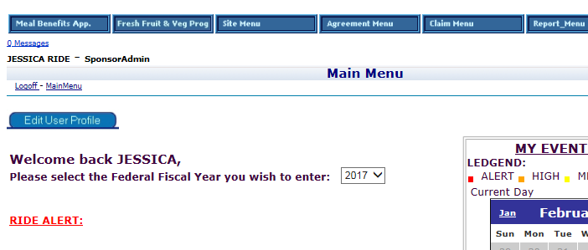

- Make sure that you click on “All” once you get to the site menu. By clicking “All” all sites associated with your agreement, closed and active, will appear on the screen.

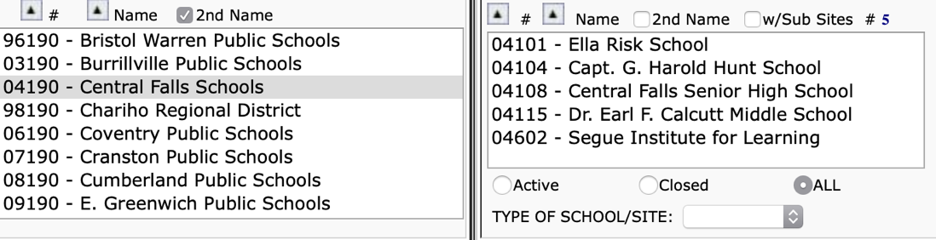

- Click on each page of the site menu (1-4) for every site listed and ensure that all information is correct or up to date.
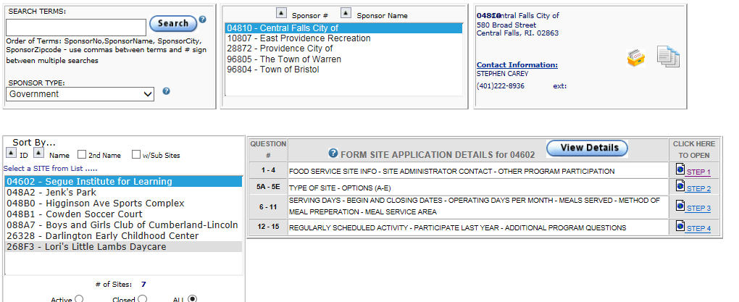

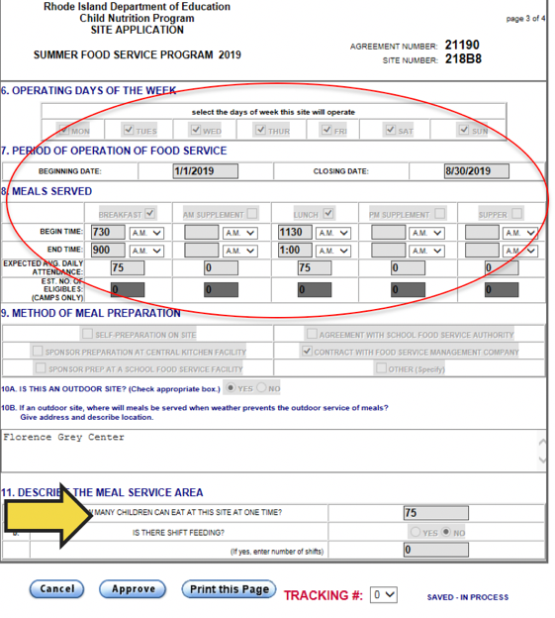

Site Menu Page 3 & 4:
- Page 3 - Pay particular attention to the
information on page 3 of the site menu as
this will affect your ability to claim &
be reimbursed for meals.
- Page 4 – Upload your preoperational visit,
if applicable.
- Remember to press save after completing
each page.

Completing the Site Menu:
- Once all 4 pages of the site menu have been reviewed and updated for each site, you will need to save the site level changes to the agreement menu:

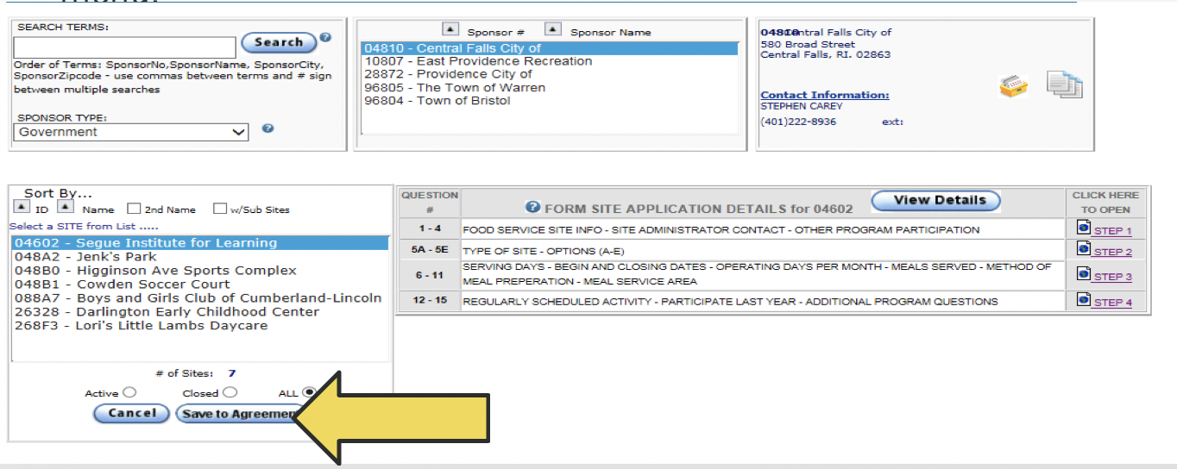

Agreement Menu:

- After saving site level changes to the agreement menu, move on to the agreement menu.
- Review each page of the agreement menu & update as necessary.
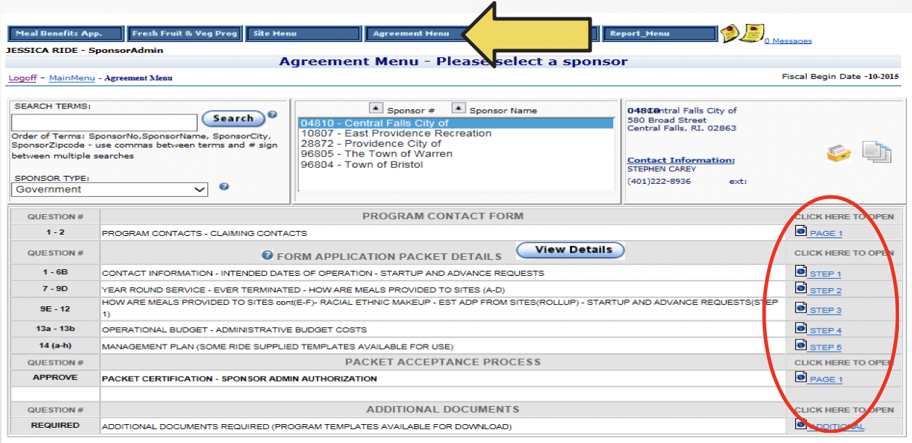

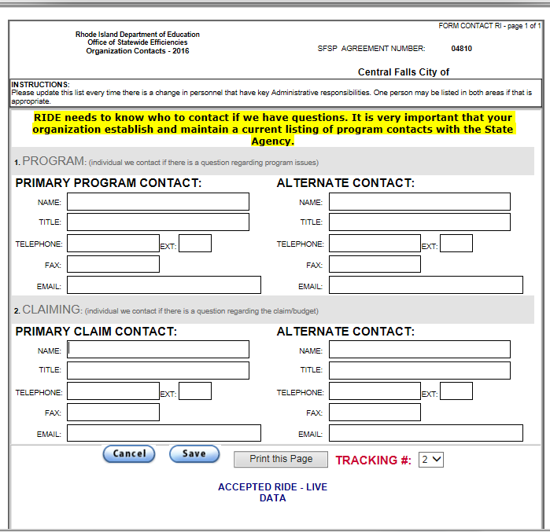
Agreement Menu – Page 1 – Contact Card
- Review and update program contact
information – this is how we will know
who to contact with any program
updates/questions

Agreement Menu – Step 1
- Review for overall accuracy.
- Information in yellow has been imported has been imported from your permanent agreement documents and cannot be changed at the sponsor level.
- Information in blue has been imported from the site menu; and issues with this information can be corrected by updating the site menu and saving those changes to the agreement.
- Sections that are greyed out are for RIDE input only.

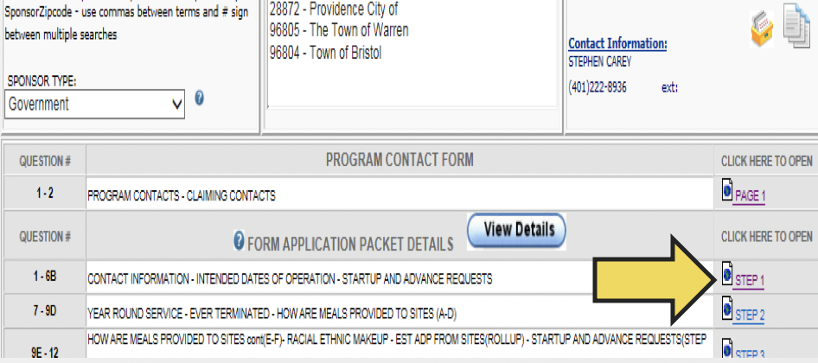

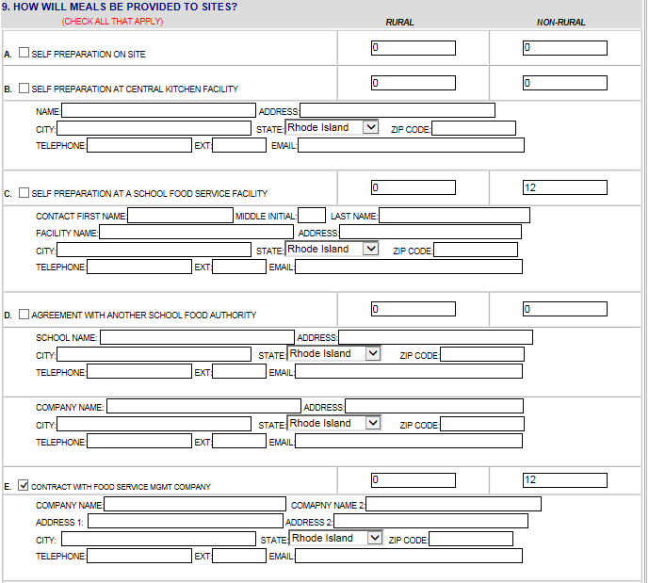
Agreement Menu – Step 2
- Answer questions 7 & 8 with current
information
- For question 9, enter the information
regarding who will be responsible for
food preparation.

Agreement Menu – Step 3
- Be sure that you upload the requested procurement documentation for any contracts that will exceed $250,000. This step is not necessary for School Food Authorities who are using their year-round FSMC for summer meals. For those who are not an SFA using a FSMC please upload either your base contract, or your current renewal.
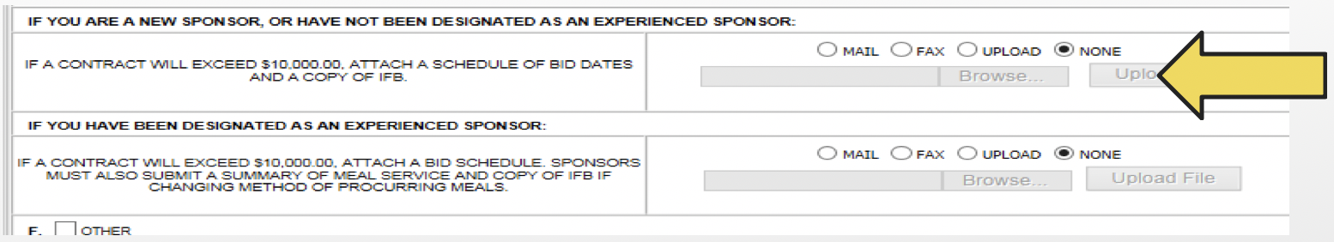

Step 3 – Question 10
- Use the most current census data provided by pressing the “view & Print” button to fill in the racial and ethnic make-up statistics.
- Entries should match the census data and should total 100%
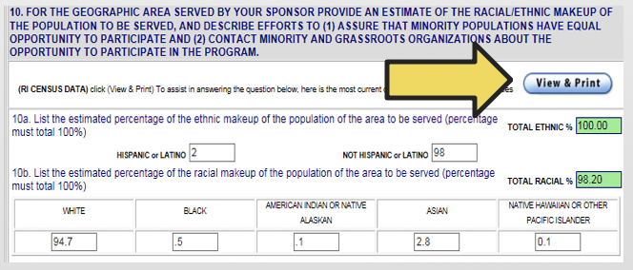
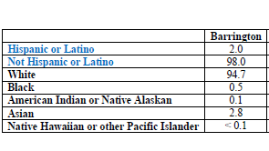

Agreement Menu – Page 4
- The management plan should be uploaded to 13A, the budget is to be completed in the Excel Spreadsheet and uploaded to question 13B.
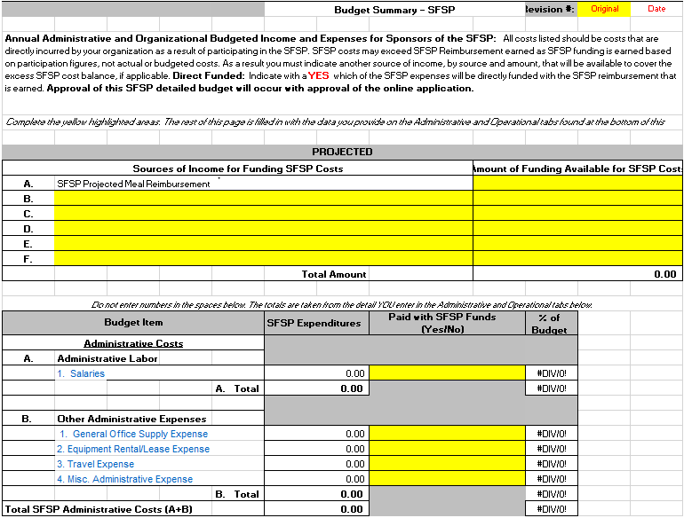
Budget Reminders:
  - Only the revenue and expenses associated
with the operation and administration of
the SFSP should be entered
  - Do not include revenues from other sources
unless they are directly supporting the SFSP
(i.e. do not include camp registration fees, etc.)
  - Do not include expenses that will not be paid
for using SFSP reimbursement dollars
  - Budgets should reflect a non-profit
food service operation
  - A budget is just a best guess – it does not need
to be 100% accurate to your actual operations
but it does need to be realistic and demonstrate
compliance with federal regulations.
  - SFA’s are not required to submit an SFSP budget

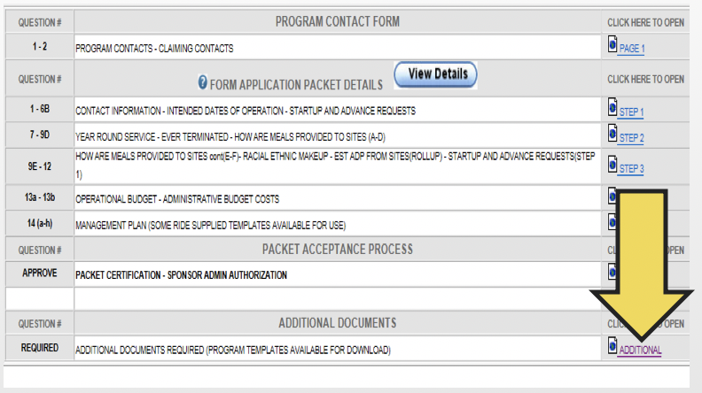
Agreement Menu – Additional Steps
- Each question in this section requires
an upload of documents specific to
your program.
- Templates for uploads are available
on the RIDE website linked here.

- A menu must be submitted for every
meal period that will be claimed.

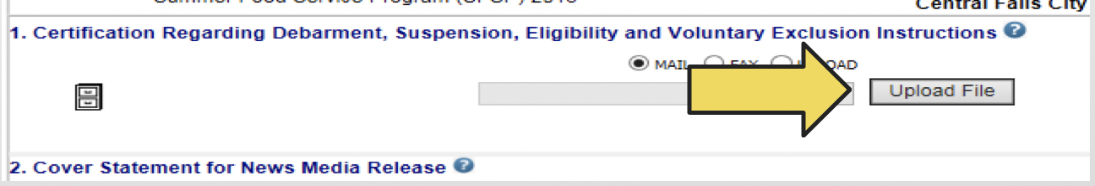

Agreement Menu – Final Steps
- Once all information has been updated in both the site and agreement menus, the agreement is ready to be approved and submitted to RIDE. Please note, that this final step can only be completed by a level 1 user.

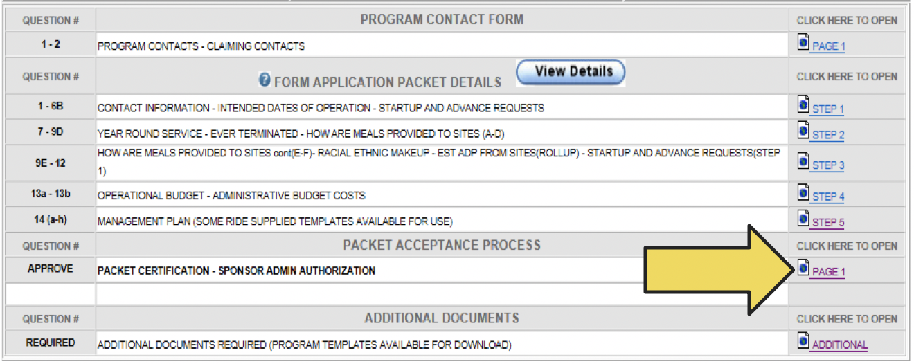

Agreement Menu – Final Steps
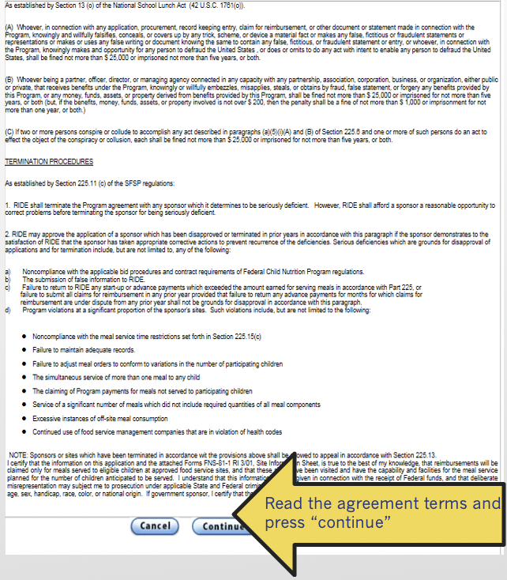

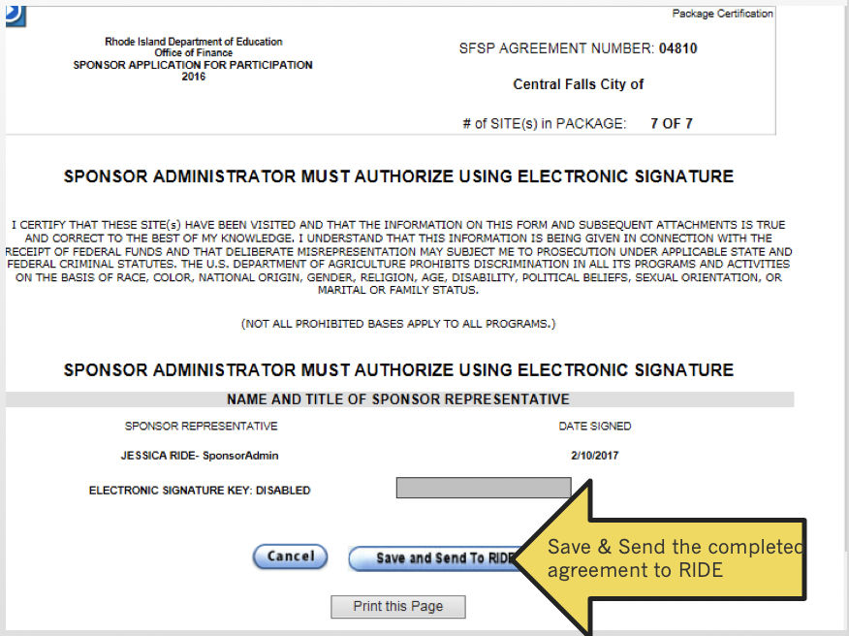

After Your Agreement Has been Submitted
- RIDE staff will review for accuracy and will follow up with any questions
- You will receive notification that RIDE has accepted your agreement and the system will be ready for you to start processing claims
- REMINDER: There are certain documents as part of the agreement packet that must be sent to other parties as well, such as the news media release and letter to DOH. Don’t forget to submit these items to the required parties and maintain documentation of the submission.

