TO: Local Education Agencies in Rhode Island
FROM: Rhode Island Department of Education (RIDE)
RE: Opportunities for High Schoolers to Earn College Credit

Earning College Credit in High School: Opportunities for RI Students

This memo summarizes the opportunities for Rhode Island high school students to earn college credit and participate in other advanced or enrichment coursework, particularly through the All Course Network (ACN) and the PrepareRI Dual Enrollment Fund.

RI students have 3 avenues to earn college credit:

- Advanced Placement Courses: At their high school or through the ACN, students can take Advanced Placement Courses developed by the CollegeBoard. RI’s three public institutions of higher education and most private colleges offer students AP credit for reaching a certain score benchmark on the AP exams in specific subject areas.

- Concurrent Enrollment Courses: At their high school, students can take a college-level course that is taught by an approved high school teacher. By passing the course, students are awarded credits that they can use at the sponsoring institution, and may be able to transfer to other institutions.

- Dual Enrollment Courses: On a college campus or through the ACN, students can take a college course taught by a professor. By passing the course, students are awarded credits that they can use at the sponsoring institution, and may be able to transfer to other institutions.

Contents:
- Course Comparison
- FAQ

- All Course Network (ACN)
- Advanced Placement (AP)
- Dual & Concurrent Enrollment

RHODE ISLAND STATE-LEVEL MECHANISMS FOR ADVANCED COURSEWORK

All Course Network “ACN”  (Courses hosted on EnrollRI Platform) |  |  |  |  | PrepareRI Dual Enrollment Fund  (RI Public Colleges)
Dual Enrollment | Advanced Placement | Work-Based Learning | Career Prep | Enrichment Courses | CCRI | RIC | URI
 |  |  |  |  | HS Enrichment  (Dual) | Dual Enrollment | Dual Enrollment
 |  |  |  |  | Stem Connect  (Concurrent) | EEP  (Concurrent) | Concurrent Enrollment
The ACN has been the network that represents/offers private college dual enrollment courses.  With the launch of Enroll RI in Spring 2021, there is an opportunity for the public colleges to offer their dual enrollment courses on this platform as well, which would streamline the dual enrollment process for students. |  |  |  |  | Students who want to take dual enrollment courses through the public colleges have had to register through the individual college programs (listed above).

What is the All Course Network? | ride.ri.gov/ACN

The All Coursework Network (formerly Advanced Course Network) is a first-of-its-kind statewide platform that increases access to enriching supplemental coursework, helping students get a head start on postsecondary success, master the skills required of a lifelong learner, and prepare for jobs in sectors critical to Rhode Island’s future prosperity.

The All Course Network is designed to help districts and schools support students by creating opportunities for them to envision, pursue, and realize their individualized graduation pathway outside of the traditional school day. RIDE recently received a federal grant (RethinkRI) and has the opportunity to significantly expand seats available on the All Course Network beginning January of 2021. This expansion means for the first time ever elementary aged students are eligible to take courses on the ACN as well!

ACN Course Types:

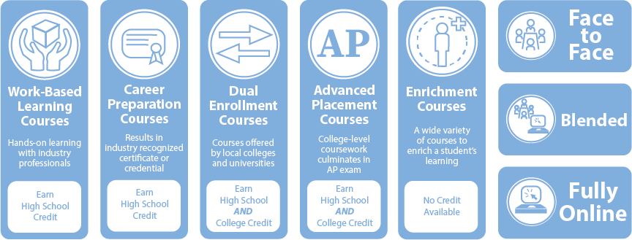

The ACN offers 5 course types. These include Dual Enrollment and Advanced Placement courses, which each culminate in both college and high school credit. In addition, students can take work-based learning courses or career preparation course, which culminate in high school credit. Starting with the 2021 expansion of the ACN, we will also offer enrichment courses for the first time (no credit associated)!

Courses are offered by colleges, schools and districts, community-based partners, and Department of Labor and Training-approved training programs to help expand course options for students around the state. The school or district which the student attends is responsible for deciding the type of credit awarded (i.e. core credit, elective, etc).

The ACN enrollment window for the 2021-22 school year will be open from May 1 to May 31st 2021. You can browse course options here and register on RIDE’s new EnrollRI platform. In addition, there is a 2 week add/drop period for each course, beginning on the first day of the course. At that time, students who enrolled in May will have the opportunity to unenroll in the course and new students will have an opportunity to join.

Advanced Placement Courses

State-level data indicates that Rhode Island students who participate in Advanced Placement (AP) coursework are substantially more likely than similar students to graduate high school, enroll in college, and bypass developmental classes at the postsecondary level (report forthcoming). If you do not currently offer AP, or you would like to offer more courses, you can follow this process outlined by the CollegeBoard.

The three Rhode Island public institutions of higher education (IHEs), as well as most private colleges, award college credit based on student’s performance on AP exams. Learn more about amount of credit offered by course below:
URI | RIC | CCRI

Making Advanced Coursework Accessible for All Students
Our analysis shows that on average, students in suburban schools have substantially more opportunities to take AP course; In 2019-20, suburban schools offered an average of 15 AP courses compared to an average of 6 in the urban core.
Nationally, research shows that low-income students, students of color, students with disabilities and language learners are all enrolled in advanced courses at disproportionately low rates in the United States.

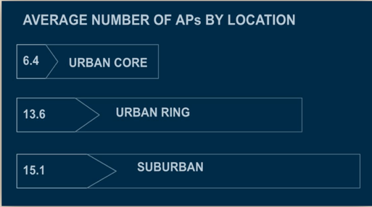

What can schools do to help combat disparity in access to advanced placement courses?
- Post AP Options Publicly: More than a quarter of Rhode Island Schools did not have information about AP options posted on their website during the 2019-2020 school year. Greater transparency can help increase awareness among students and families about their advanced coursework options. This Spring, RIDE is strongly encouraging every LEA to post their AP options online.

- Collect and Disaggregate Data: Collect data on participation and performance in advanced coursework at your school. Disaggregate data by student demographic characteristics to see if there are disparities in who is accessing this opportunity. Set clear and measurable goals for increased participation and performance.

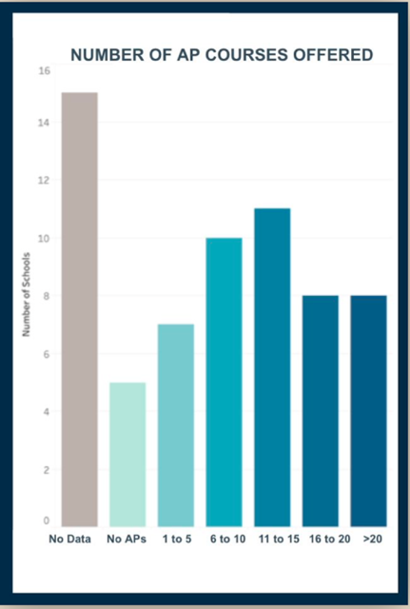

- Adopt Open Admissions Policies: With the additional challenges of the AP curriculum, many schools across the country use “selection criteria” to place students into advanced classes. However, our Rhode Island state data shows that participation in AP classes is associated with a large increase in likelihood of graduating, enrolling in college and bypassing remediation, including for students who were not traditional high-achievers. Furthermore,
research shows that many criteria like test scores or teacher recommendations can disproportionately limit access for underserved students. Consider adopting open admission policies in which any student who is interested can participate in AP classes; some schools have also instituted “opt out” programs in which all students are automatically registered for key AP classes.

- Use Accessible Language to Talk about AP: Research suggests that students of color are less likely to believe that they belong in advanced courses. In communication with students and colleagues about who should participate in advanced work, consider emphasizing qualities like work ethic and growth mindset instead of seeking students who are perceived as the “smartest.” Emphasize the following qualities of an advanced student:
    - Interested in challenging yourself
    - Interested in preparing for college
    - Interested in becoming a better critical thinking
    - Hard worker
    - Willing to use mistakes as an opportunity to learn
    - Belief that with practice, academic skills will get stronger
Beyond adopting open enrollment policies, it is important to actively recruit students from all background to try advanced coursework.

- Provide Additional Academic Supports: Traditionally, advanced courses might be perceived as a placement for students who are already academically successful and thus need limited support. Instead, think of advanced courses as a space for all students to have the opportunity to gain college- and career-relevant skills. To enable every student to succeed in rigorous classes, it is important to continue providing, and even augment, academic supports.

In addition to taking AP courses through their high school, RI students also have the opportunity to take select APs through the All Course Network. Taking an AP course through the ACN is free, including taking the AP exam. The CollegeBoard also has fee reduction options to support low-income students in taking the exam.

Dual & Concurrent Enrollment

Concurrent Enrollment courses are college-level classes that are offered at a high school campus and taught by an approved high school teacher. In contrast, Dual Enrollment courses are taught on a college campus by a college professor. Both types of classes offered both high school and college credit. Students can participate in both types of courses for FREE via the PrepareRI Dual Enrollment Fund.

State-level research indicates that students who participate in concurrent enrollment and dual enrollment are substantially more likely than similar students to graduate high school, enroll in college, and bypass developmental classes at the postsecondary level (report forthcoming). All three RI public colleges and universities offer both concurrent and dual enrollment opportunities. LEAs that are interested in offering a concurrent course can refer to the institution-specific links below. Students register for Dual Enrollment directly through the institution, with the help and approval of their guidance counselor.

PrepareRI Dual Enrollment Fund | ride.ri.gov/DualEnrollment

Governor Raimondo’s PrepareRI Dual Enrollment Fund allows any public high school students to access dual enrollment courses with the University of Rhode Island (URI), Rhode Island College (RIC), and Community College of Rhode Island (CCRI) at no cost to the student or their family. There are two types of advanced coursework accessed through this program: one is dual enrollment in which the student is taking a college course on the college campus; the other is called concurrent enrollment, in which the college course is taken on the high school campus and taught by a college- approved high school teacher.

Dual and Concurrent Options at Rhode Island’s Public IHEs:

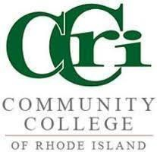
Community College of Rhode Island (CCRI)
STEM Connect: STEM Connect is the name of CCRI’s concurrent enrollment course options. High schools around the state can apply to offer these courses on the high school campus for high school credit. The course options available will vary by school. More information can be found here: https://www.ccri.edu/oes/admissions/partnerships/HSCCRIpartnership.html

High School Enrichment: High School students have access to CCRI’s course catalog for dual enrollment courses. A list of recommended dual enrollment courses is available on ride.ri.gov/dualenrollment. Any course paid for by the PrepareRI dual enrollment fund must be approved by the student’s high school to count for elective or core high school credit. More information can be found here: https://www.ccri.edu/oes/admissions/partnerships/highschoolenrichment.html

Running Start: In addition to part-time dual enrollment courses, CCRI offers a full-time dual enrollment option that a student’s home district is financially responsible for, called Running Start. Running Start is a full-time senior year dual enrollment program. Students who enroll in this program will not take courses at their high school in their twelfth-grade year, but rather take all of their courses for college credit at CCRI. Students are considered non-matriculated, meaning that any student who wishes to attend CCRI the year following their senior year will need to reapply as a degree applicant. Students apply in early spring of their junior year. More information can be found here: https://www.ccri.edu/oes/admissions/partnerships/runningstart.html

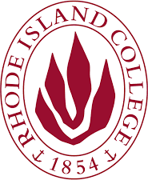
Rhode Island College (RIC)
Early Enrollment Program (EEP): EEP is the name of RIC’s concurrent enrollment course options. High schools around the state can apply to offer these courses on the high school campus for high school credit. The course options available will vary by school. More information can be found here: http://www.ric.edu/eep/Pages/default.aspx

Dual Enrollment: RIC does not have a branded name for their dual offerings, but high school students have access to RIC’s course catalog for dual enrollment courses. Any course paid for by the PrepareRI Dual Enrollment fund must be approved by the student’s high school to count for elective or core high school credit. More information can be found here: http://www.ric.edu/eep/Pages/Dual-Enrollment.aspx

University of Rhode Island (URI)
Concurrent: URI does not have a branded name for their concurrent offerings but high schools around the state can apply to offer these courses on the high school campus for high school credit. The course options available will vary by school. More information can be found here: https://web.uri.edu/ceps/concurrent-enrollment-program/

Dual Enrollment: URI does not have a branded name for their dual offerings but more information can be found here: https://web.uri.edu/osi/programs/dual-enrollment/

Course Comparison

 | Advanced Course Network |  |  |  | PrepareRI Dual Enrollment Fund |  |  |  |  |  | Full-time Dual Enroll.
I want to… | Work- based Learning | Career Prep | AP  Classes  (one online course this year) | College Courses (Dual) | CCRI - STEM  Connect (Concurrent) | CCRI - High School Enrichment (Dual) | RIC - Early Enrollment Program (Concurrent) | RIC - Dual enrollment (Dual) | URI  Concurrent Enrollment (Concurrent) | URI  Dual Enrollment (Dual) | CCRI  Running Start | URI  Early Enrollment
Location
Take courses on a college campus.
Take courses online.
Take courses at my high school.
Take courses other than at my high school or a college.
Program Type+
Enroll in a full-time program for senior yr.
Take additional courses for HS credit and still be at my HS.
Take courses a la carte to complete my HS reqs without taking courses at my school.
Credit Type+
Earn college credit.
Possibly earn a career credential I can use now or after HS.
Explore a new topic but not get college credit at this time.
Costs
/can pay for my transportation costs.
/can pay limited expenses for the course. (i.e. a test fee)
/can pay all expenses for the course. (i.e. tuition)
+ The school or district approves or denies a student taking courses to complete graduation requirements. If necessary, appeal options exist at the district and state level.

FAQs

Q1: What happens if a student takes a dual or concurrent course and receives a failing grade?
A: If a student takes a dual or concurrent course and receives a failing grade, that grade stays on the student’s permanent postsecondary transcript. This is an important consideration as it can jeopardize a student’s application to colleges and certain types of financial aid. Students should consult with their schools to make sure that they are academically prepared to do well in college-level coursework.

Q2: Who pays for the textbooks required for dual enrollment students at CCRI, RIC, and URI?
A: According to a Commissioner’s decision in 2016, full and part-time dual enrollment student costs and course materials (ex: art supplies) are to be covered by the local education agency (LEA). LEAs may choose to implement this policy in various ways; some choose to reimburse students for their textbook costs and some choose to purchase the textbooks outright and loan them to students for the year. Each institution has developed ways to allow for direct billing of districts for these textbooks to avoid any financial barrier to participation for students.

Q3: Who pays for tuition and fees for students in the Running Start and other full-time programs with CCRI?
A: The Rhode Island Board of Education’s Regulations on Dual Enrollment establish that districts pay all tuition and fees for students enrolled in full-time dual enrollment programs with CCRI. Students who would like to take summer courses after graduating from high school should contact the office of enrollment services at CCRI.

Q4: Can homeschooled or private/parochial school students take advantage of the Advanced Course Network and/or dual and concurrent enrollment with the public institutions?
A: Yes, these opportunities are available to home school and students enrolled in private schools. However, the state funding is designated for students enrolled in a public school and so these students would be responsible for the associated costs of taking a course, and they would have to register directly with the school or providers.

Q5: Are remedial courses at CCRI, RIC, or URI covered by the PrepareRI Dual Enrollment Fund?
A: No. URI, RIC and CCRI all have remedial courses, but they are not covered by the dual enrollment fund. A course number that begins with “0” (zero) can typically identify these courses. If you have questions about whether a course is considered remedial, ask the college before registering for the course.

Q6: Can I take an ACN course if I have graduated from high school?
A: The ACN was created for high school students to challenge themselves during high school and get ahead in college. Students who have graduated high school are no longer eligible to participate.

Q7: Are these course credits transferable to other universities and colleges?
A: All students earn transcript credit by taking college level courses in the ACN and through the PrepareRI Dual Enrollment Fund. Students are able to send transcripts to the institution they plan to attend full-time. Each institution of higher education that receives these transcripts will have their own policies and procedures for reviewing credit taken at other institutions. If a student is aware of an institution/program that they want to enroll in after high school, they should call that institution’s admission office to obtain their credit transfer policy.

Q8: Is there a course limit to the number of courses I can take as part of the ACN?
A: We want students to be successful, so they are currently eligible to take: one course over the summer through the ACN and no more than two at a time during the fall and spring semesters.

Q9: Is there a course limit to the number of courses I can take as part the PrepareRI Dual Enrollment Fund?
A: Generally, students are limited to two courses per fall and spring semesters for dual enrollment coursework with RIC, URI, or CCRI, unless enrolled in a full-time program (example: Running Start). The PrepareRI Dual Enrollment Fund does not limit participation in concurrent enrollment coursework per semester, however local high schools may enforce their own policies.

Q10: Does the PrepareRI Dual Enrollment Fund include summer coursework with RIC, URI, or CCRI?
A: No, the PrepareRI Dual Enrollment Fund does not cover summer coursework with RIC, URI, or CCRI. Students can take these classes at CCRI, RIC, or URI but the student would be responsible for all tuition, fees, and registration.

Q11: If I am taking classes on a college campus, do I have to take PE and Health?
A: If a student is in 12th grade and is enrolled in a full-time dual enrollment program where the courses are taken on a higher education institution campus (CCRI’s Running Start program and URI’s Early Enrollment program this year) they do not have to complete health and PE classes as determined by recently passed legislation in January of 2019.

For follow up questions please contact elizabeth.lindgren@ride.ri.gov

