General Problem Solving Strategies | Symbols
- Reread question for clarity  - Draw a Picture  - Make a table  - Circle or highlight key terms  - Calculate and solve  - See if my answer makes sense  - Circle my answer | $>$ is greater than  $<$ is less than  $=$ is equal to
Place Value | Divisibility Rules
  Whole Numbers |  |  |  |  |  |  | Decimals
  Ht | Tt | Th | H | T | O | . | T | H | Th
  2 | If the last digit is even
  3 | If the sum of the digits can be divided by 3
  5 | If the last digit is 0 or 5
  6 | If the number is divisible by both 2 and 3
  9 | If the sum of the digits can be divided by 9
  10 | If the last digit is 0
Number Line
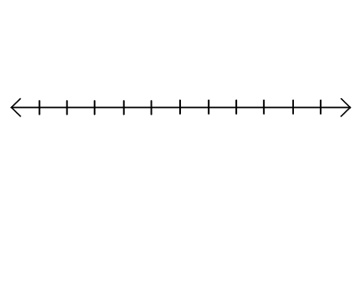
Devices | Perimeter (P )
PEMDAS | Perimeter $=distance around$
Hundreds Chart | Coordinate Plane
 | 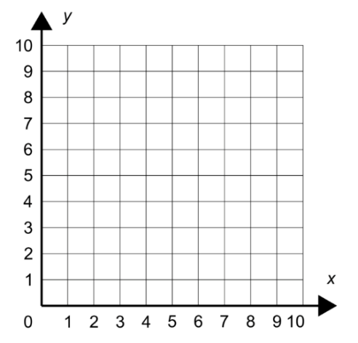
  1 | 2 | 3 | 4 | 5 | 6 | 7 | 8 | 9 | 10
  11 | 12 | 13 | 14 | 15 | 16 | 17 | 18 | 19 | 20
  21 | 22 | 23 | 24 | 25 | 26 | 27 | 28 | 29 | 30
  31 | 32 | 33 | 34 | 35 | 36 | 37 | 38 | 39 | 40
  41 | 42 | 43 | 44 | 45 | 46 | 47 | 48 | 49 | 50
  51 | 52 | 53 | 54 | 55 | 56 | 57 | 58 | 59 | 60
  61 | 62 | 63 | 64 | 65 | 66 | 67 | 68 | 69 | 70
  71 | 72 | 73 | 74 | 75 | 76 | 77 | 78 | 79 | 80
  81 | 82 | 83 | 84 | 85 | 86 | 87 | 88 | 89 | 90
  91 | 92 | 93 | 94 | 95 | 96 | 97 | 98 | 99 | 100

Area Model | Metric Conversions
Area ($A$) of Rectangle $A=l ×w$  ($l=length;w=width$) | 1 kilometer (km) = 1000 meters (m)  1 meter (m) = 100 centimeters (cm)  1 meter (m) = 1000 millimeters (mm)  1 kilogram (kg) = 1000 grams (g)  1 liter (L) = 1000 milliliters (mL)
  $l$
  A | $$w$$
Multiplication Table (Do NOT complete this table for the student.)

X | 1 | 2 | 3 | 4 | 5 | 6 | 7 | 8 | 9 | 10 | 11 | 12
1
2
3
4
5
6
7
8
9
10
11
12

Fractions Bars (Do NOT complete this table for the student.)

