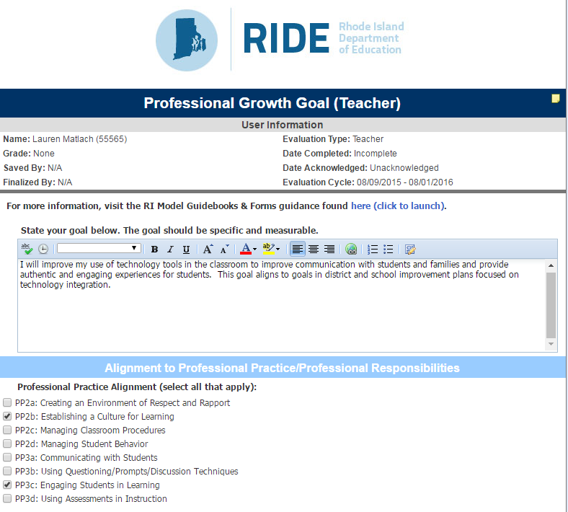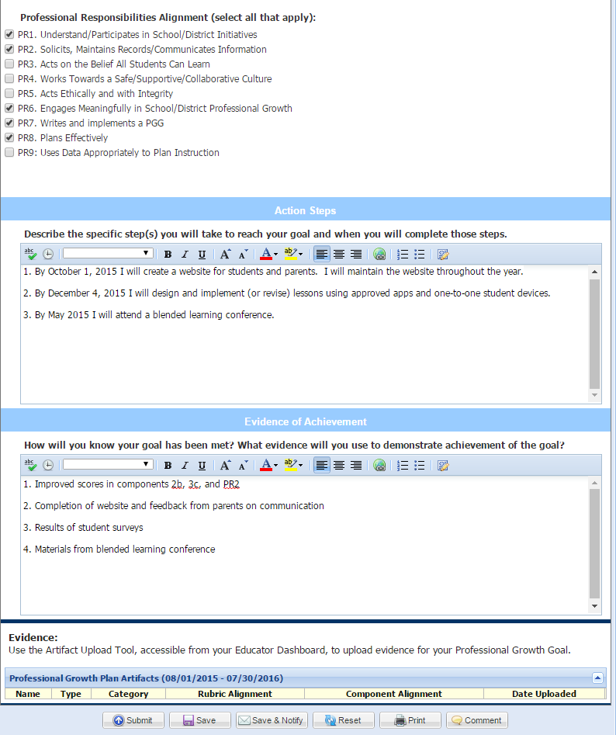
Kristen Galante
6 Math

The following artifacts are provided:
- There is only marginal change in scores from components 2b and 3c. There is moderate score change from component PR2.

- Website screenshots from October, December, and April – each iteration looks different and better, revised as a result of student and parent feedback about ease of use, clarity, and design.

- There is evidence from one student survey given in November. While the results mostly indicated that students feel their learning experiences are engaging because of the teacher’s use of technology, some offered that the directions aren’t always clear and frustration often ensues.

- Did not attend Blended Learning Conference because it was canceled
  - Email submitted as proof the conference was canceled due to inclement weather; it was not rescheduled

